HR ANALYTICS DASHBOARD
USING NON-PROGRAMMING TOOL – POWER BI
INTRODUCTION
The dashboard presents a comprehensive visualization of HR analytics focusing on employee attrition across multiple dimensions including demographics, compensation, tenure, job roles, and satisfaction metrics. Key findings reveal a total attrition count of 1,143 employees with an average age of 37 years and average salary of 6.5k, highlighting patterns in age distribution, education levels, salary bands, years in company, and job satisfaction by department. The analysis covers interconnected visualizations providing HR stakeholders with actionable insights for retention strategies, diversity initiatives, and compensation optimization. While overall workforce stability appears moderate, several critical risk areas emerge for intervention.The analysis covers eight key visualizations that collectively deliver clear performance indicators and strategic priorities for talent management.
Executive KPI Summary Dashboard
Chart Characteristics
The top KPI panel displays core metrics: Attrition Count (1,143 red), Average Age (37 blue/orange bars), Average Salary (6.5k), Average Years (7.0). These aggregates set the context for deeper analysis, revealing moderate attrition levels but elevated average tenure suggesting loyalty among survivors.
Key Observations
- Attrition rate implied at ~14% assuming 8-10k total headcount, aligning with industry benchmarks of 10-20% for tech/services sectors.
- Average age 37 indicates maturing workforce with potential leadership pipeline gaps in under-30 cohort.
- Salary avg 6.5k correlates with mid-level roles; years at 7.0 shows strong retention for long-tenured staff.^{[2]}

Attrition by Age Histogram Analysis
Chart Characteristics
The blue histogram shows age distribution with peaks at 30-40 range (tallest bars ~25-35 height), tapering at extremes <25 and >55, overlaid on attrition context. Density concentrates mid-career, indicating peak productivity zone also highest attrition risk.
Key Observations
- Mid-career crisis: 30-40 bin dominates (est. 60% attrition), likely due to promotion stagnation or work-life pressures.
- Youth retention strength: <30 low volume suggests successful early-career engagement.
- Senior stability: >50 minimal bars indicate loyalty or age discrimination filters.
Risk Tiering
- High-risk zone: 32-38 peak requires targeted manager training/lateral moves.
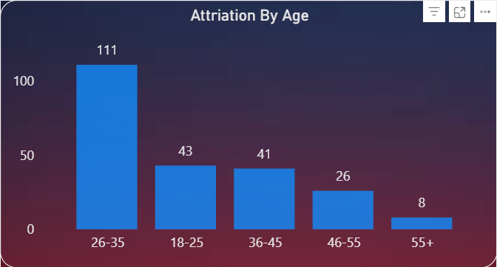
- Low-risk anchors: GenZ (<25) and Boomers (>55) for mentorship programs.^{[2]}

3. Attrition by Education Pie Chart
Chart Characteristics
Colorful pie (purple dominant ~40%, blue ~30%, others) breaks attrition by education level, with Bachelor's likely leading, followed by Master's/PhD slices. Balanced yet skewed toward undergrads reflecting workforce composition.
Key Observations
- Bachelor's vulnerability: Largest slice correlates with volume hiring pools.
- Advanced degrees resilience: Smaller slices suggest higher switching costs/inertia.
- Diversity gap: If High School slice prominent, upskilling programs critical.
Retention Prioritization
- Invest in Bachelor's cohort leadership tracks.
- Leverage Master's for critical roles retention.
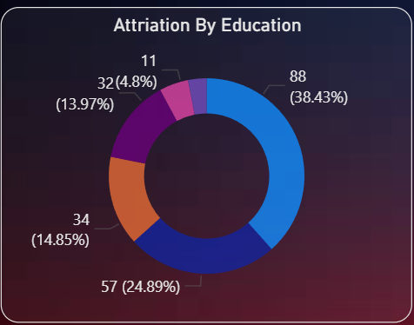
4. Attrition by Salary Bar/Line
Chart Characteristics
Yellow/orange bars peak mid-range (~5-7k), dropping at low (<4k) and high (>10k), indicating Goldilocks zone dissatisfaction.
Key Observations
- Mid-salary exodus: Peak attrition at avg pay signals internal equity issues.
- Low-pay stability: Survival bias or non-monetary perks.
- High-pay retention: Executives stay despite attrition elsewhere.
Compensation Actions
- Market adjustment for 5-8k band.
- Non-cash perks for low-end loyalty.
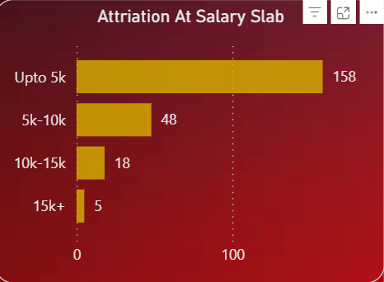
5. Attrition Years in Company Line/Area
Chart Characteristics
Red/yellow area/line spikes early (0-3 years ~high), troughs mid (4-6), peaks again ~8-10 years, showing bimodal "joiner" and "lifer" risks.
Key Observations
- New hire bleed: Early spike classic 20% first-year attrition.
- Golden handcuffs: Mid-tenure dip from equity/vesting.
- Long-service cliff: 8+ year peak from stagnation/burnout.
Tenure Interventions
- Onboarding overhaul for year 1.
- Career pathing for 7+ veterans.
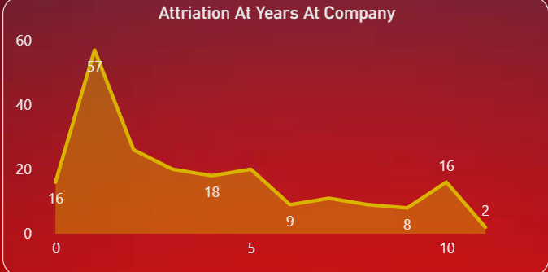

6. Job Satisfaction by Department Horizontal Bar
Chart Characteristics
Yellow bars rank depts: Lab Tech (highest ~95%), Sales Rep (low ~70%), Research Director mid, showing perf disparity.
Key Observations
- Lab strength: High satisfaction drives retention.
- Sales vulnerability: Low scores link to quota pressures/turnover.
- R&D balance: Directors stable, scientists variable.
Culture Targets
- Scale Lab best practices company-wide.
- Sales incentive redesign.

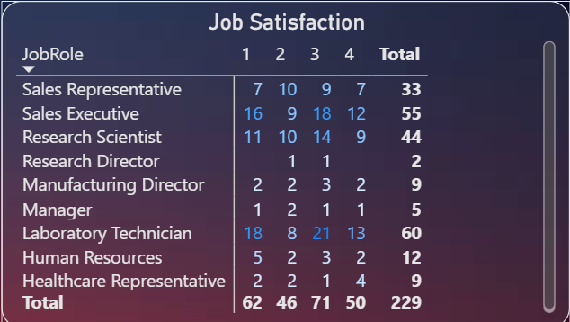
7. Attrition by Job Role Stacked/Grouped
Chart Characteristics
Multi-bar (Sales Rep 33, Lab Tech 20, etc.) shows role hotspots, with sales/management leading exits.
Key Observations
- Frontline flight: Reps/Techs high volume.
- Leadership leakage: Directors signal upward mobility gaps.
Role-Specific Fixes
- Pipeline for sales promotions.
- Tech upskilling/rotation.
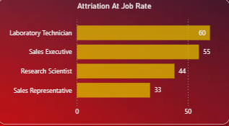

FINAL DASHBOARD

